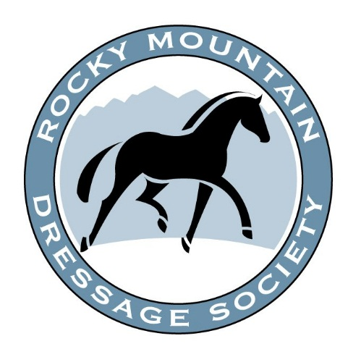
THE TECHNICAL DELEGATE (TD)
a resource for competitors, judges,
and competition management

The TD for this competition is: ____________________

I am here to:
- Safeguard the welfare of the horse.
- Help management provide a safe and fair competition for all.
- Protect the interests of competitors, judges and competition management.
- Answer your questions and respond to your concerns.

Need the TD?

Ask the show office to radio me or call/text _____________

