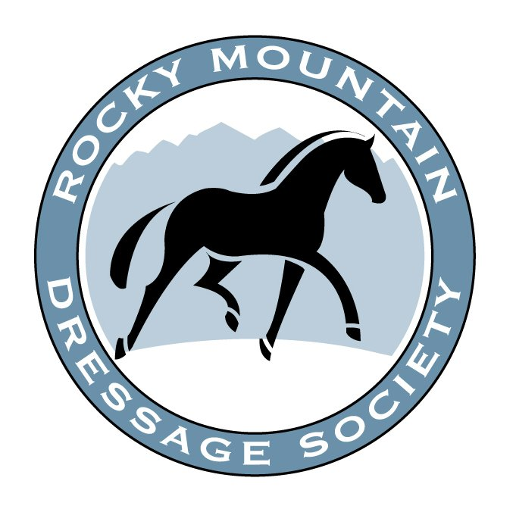RMDS Professionals’ Symposium
Featuring Lilo Fore
April 24-25, 2021
(Saturday and Sunday)
Tomora Training Center, Greeley, Colorado

PROFESSIONAL TRAINERS – THIS IS FOR YOU!!!
Join us for two days of Dressage Education with
LILO FORE
Lilo Fore hardly needs an introduction to the Dressage community! She is the Judge everyone wants to ride for. Her scores make and comments give you exactly the information you need to improve. As a Clinician who is always in demand, she has something to offer at every level. Lilo is a Master teacher, Master Trainer, and all around excellent human being.

You DO NOT WANT TO MISS THIS OPPORTUNITY to work with Lilo in your own back yard!
IF YOU ARE A 2021 member of RMDS
and a declared professional of ANY equine discipline,
YOU CAN ATTEND AS AN AUDITOR.
YOU MAY ALSO APPLY AS A RIDER [read below] Nonmember professionals may also attend at the nonmember rate.

What is this Trainer’s forum about? It’s about providing a 2-day clinic, with a world class trainer, in a venue where training concepts can be observed and discussed. Lilo has the depth of experience to provide solid education at ALL levels. Every level of ability is welcome and encouraged to attend!

Every trainer needs time to sharpen their eye, refresh their motivation, and get re-inspired.

Do you HAVE to talk? Only if you are a rider being asked a question!
Can you ask why the rider sitting crooked is not having their seat addressed? You bet!

The Symposium will run approximately 8:30am-5pm each day with registration beginning at 8am. Box lunches will be provided for all pre-registrants and demonstration riders
INSANELY LOW FEE
For Participants:
In Advance: $150 Full Event (includes lunch each day) or $80 per day (includes lunch)
Nonmember rates are $225 and $125 respectively
At the Door: $185 Full Event (no lunch) or $95 per day (no lunch)
Nonmember rates are $260 and $135 respectively
Demonstration Riders:
$275 – one ride each day plus your lunch. Professional riders only. If horse is owned by amateur or junior client, the client may attend ONLY the session for their horse as a silent auditor.
Nonmember rate is $350
For Demonstration Rider Application, please see www.rmds.org.

RMDS Trainer’s Seminar Participant Registration | Lilo Fore

Name: Email:

Address:

Phone: Dietary Needs:

In Advance (By March 24, 2021):

_______$150 Full Symposium (includes lunch each day) $225 Nonmember

_______$80 per day (includes lunch) CIRCLE ONE: SATURDAY or SUNDAY $125 Nonmember

For Questions please contact Beth at rmds@rmds.org or 720-890-7825
Make checks out to RMDS and send to RMDS, 2942 Park Lake Dr, Boulder, CO 80301
or make your payment online at http://rmds.org/Main/Payment

