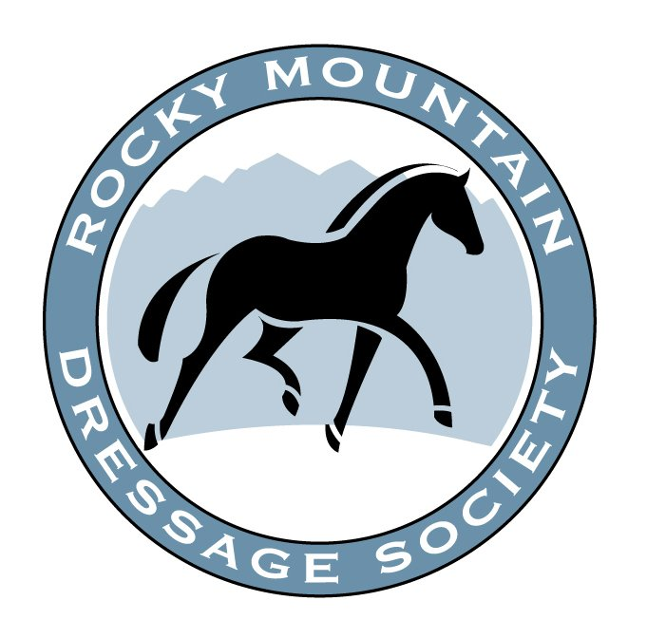RMDS Professionals’ Symposium
Featuring Lilo Fore
April 24-25, 2021
(Saturday and Sunday!)
Tomora Training Center, Greeley, Colorado

RIDER APPLICATION (Professionals Only) – Closing Date March 15, 2021
Lilo Fore hardly needs an introduction to the Dressage community! Our hope is to present Lilo with 4 National and 4 FEI level combinations. This is an extremely unique opportunity to ride with a brilliant trainer and discuss the process while you train!

Applications are open from now until March 15th, with riders being notified of their status by March 25th.
Video of horse/rider combination required. Please use a YouTube web link to apply. Video should include all 3 gaits, both directions, and a sample of movements used at the level you are applying. Test rides are fine. Video is not to exceed 6 minutes. Videos not abiding by these requirements will not be considered!

The Symposium will run approximately 8:30am-5pm each day with registration beginning at 8am. Box lunches will be provided for all demonstration riders.
COST: $275 for TWO lessons over TWO days with TWO lunches included! Non RMDS Member fee is $350.

Send video links and rider applications to Beth Geier at the central office: rmds@rmds.org

RMDS Rider Application | Lilo Fore

Name: Email:

Address:

Phone: Dietary Needs:

Horse: Level:

Brief Description of horse and rider: (add a sheet if needed)
Payment Method: _________________________________ Cost: $275.00

For Questions please contact Beth at rmds@rmds.org or 720-890-7825
Make checks out to RMDS and send to RMDS, 2942 Park Lake Dr, Boulder, CO 80301
or make your payment online at http://rmds.org/Main/Payment

